A robotic arm has two links with $L_{1}=1.2 m$, and $L_{2}=0.8 m$. The end effector needs to move from point A [-1.2, 0.9] to B [1.1, 0.8].

1.2 m

0.8 m

A [-1.2, 0.9]

B [1.1, 0.8]

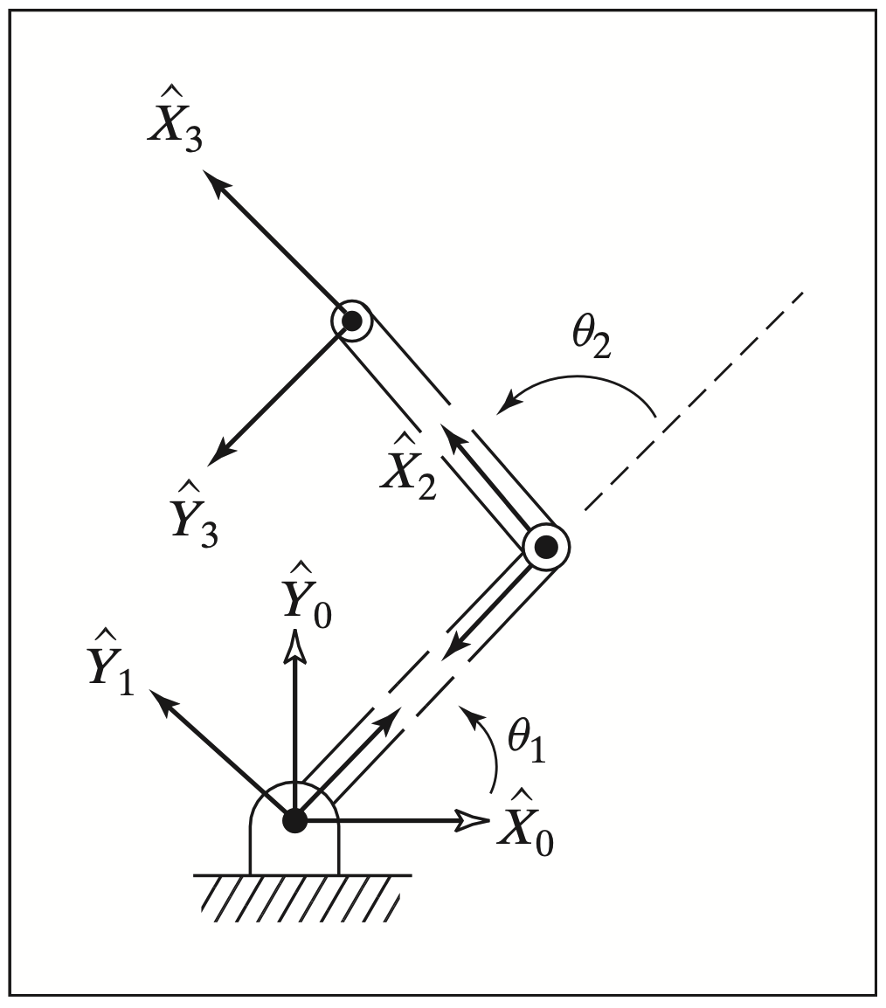

=45°

=80°

1. Please use basic linear interpolation method. The maximal acceleration of each joint is $3\frac{rad}{s^{2}}$ and the maximal speed of each joint is $1.5\frac{rad}{s}$. Please plot the result with angles $θ_{1}$ and $θ_{2}$ vs. time. Please also animate the final result.



2. Please do the same with third order polynomial interpolation method. This time, it is required to get to the destination within 2 seconds. Did you see any difference between those two? What does those differences mean?



3. Now there is a via point C [0, 1.3] and it is required to get there by 1 s with angular velocity of -1 rad/s in both ${\dot{θ}}_{1}$ and ${\dot{θ}}_{2}$. The whole process takes 2 seconds. Please plot the result and show the animation.

